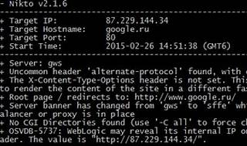

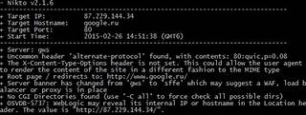

Explore

Certainly! **Nikto** is an **open-source web server and web application scanner** that performs comprehensive tests against web servers to identify vulnerabilities, outdated software, and other security issues. It can help you assess the security posture of your web applications and servers. Here are some free resources to learn more about Nikto:

1. [**Web Server Scanning With Nikto – A Beginner’s Guide**: This detailed guide on freeCodeCamp provides an introduction to Nikto, installation instructions, and examples of how to run scans1](https://www.freecodecamp.org/news/an-introduction-to-web-server-scanning-with-nikto/).
2. [**Nikto Cheat Sheet - Commands & Examples**: A comprehensive cheat sheet with commands and examples for customizing Nikto scans](https://www.freecodecamp.org/news/an-introduction-to-web-server-scanning-with-nikto/)[2](https://highon.coffee/blog/nikto-cheat-sheet/).
3. [**Nikto 2.5 Documentation**: The official documentation for Nikto, including detailed information on usage, options, and features](https://www.freecodecamp.org/news/an-introduction-to-web-server-scanning-with-nikto/)[3](https://cirt.net/nikto2).
4. [**Nikto Tutorial - Installation to Effective Targeting**: A step-by-step tutorial covering installation, scanning techniques, and effective targeting using Nikto](https://www.freecodecamp.org/news/an-introduction-to-web-server-scanning-with-nikto/)[4](https://hackertarget.com/nikto-tutorial/).
5. [**YouTube Video: Nikto Web Vulnerability Scanner - Web Penetration Testing**: Watch this video tutorial to see Nikto in action and learn how to use it for web security testing](https://www.freecodecamp.org/news/an-introduction-to-web-server-scanning-with-nikto/)[5](https://www.youtube.com/watch?v=GH9qn_DBzCk).

Remember to use Nikto responsibly and always obtain proper authorization before scanning any systems or networks. Happy learning! 🚀